After I uploaded my photo
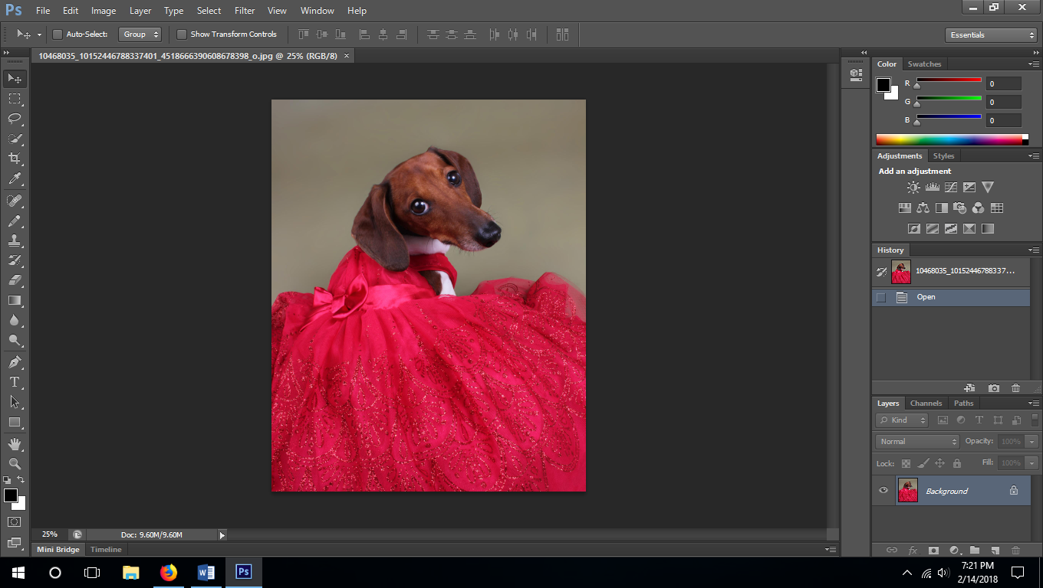
Go to image, mode, and grayscale.
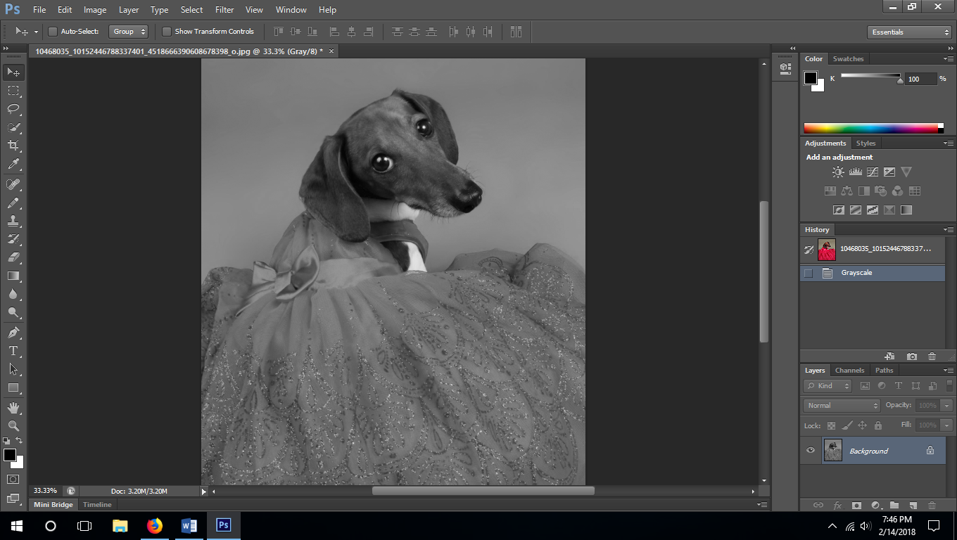

You are then going to go to filter, sharpen, and unsharp mask. You want a lot of detail to show. As a photographer it was a very slow process to get to where I went very dramatic with this. You are going to super over expose, add a lot of contrast, and do a lot of sharpening. After a lot of trial and error, I realized that these regular photo editing rules do not apply at all with this.
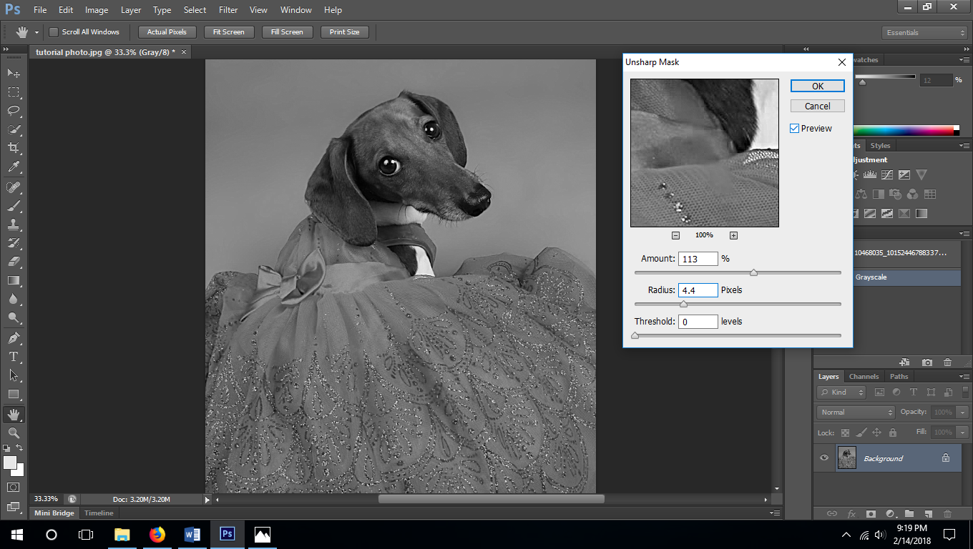
Next comes Image, adjustments, and brightness and contrast. And probably image, adjustments, and curves. You don’t want to lose too much detail by adding too much white or removing too much black. Just keep messing with it. I also go back with the Dodge tool with shadows at light exposure (for less detail). And burn tool at with highlights at light exposure (for more detail).
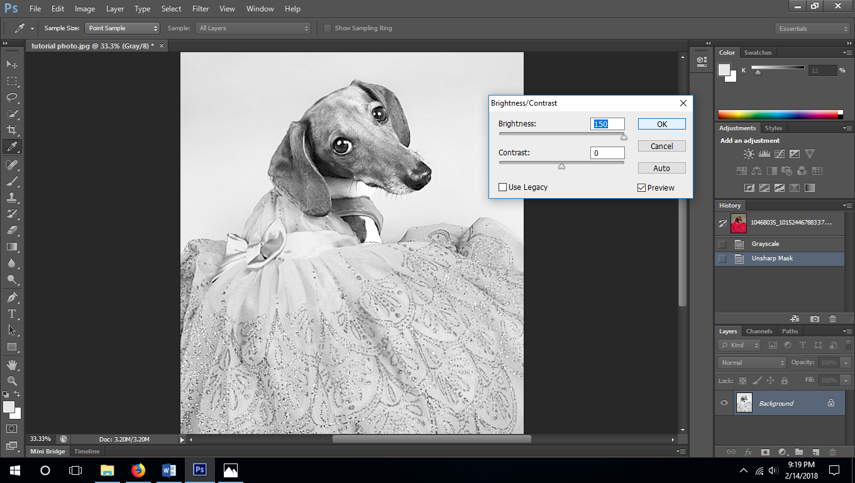
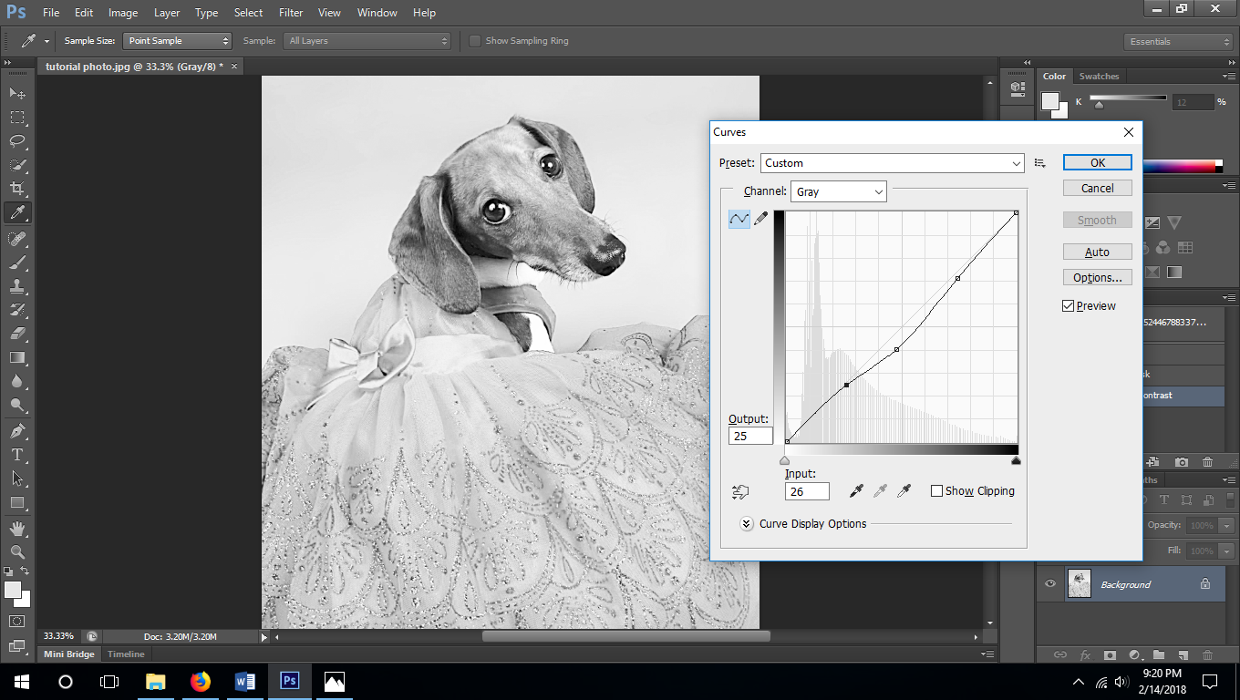

I have to make the dress darker because the head is darker which means that the head is going to be further than the dress and it will look odd. The Darker the color, the more it engraves. So I just select the dress by itself. To do that, I use mask with a paint brush to make it easier to select what I want and then inverse what I selected
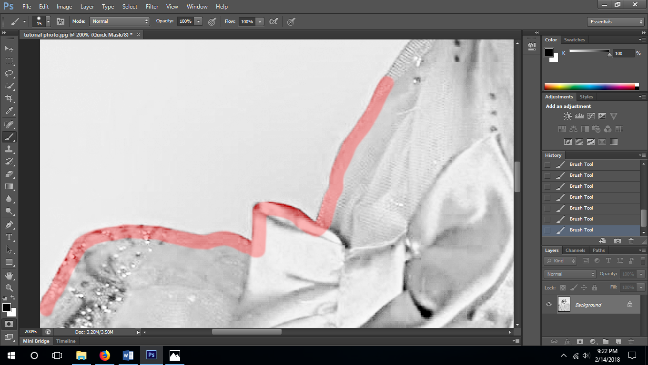
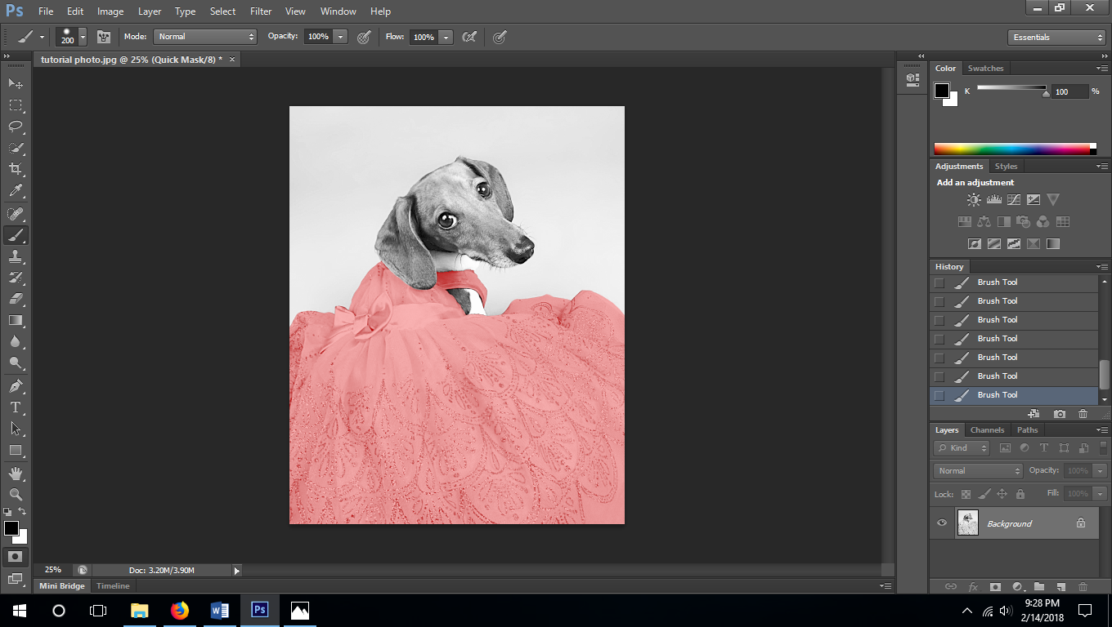
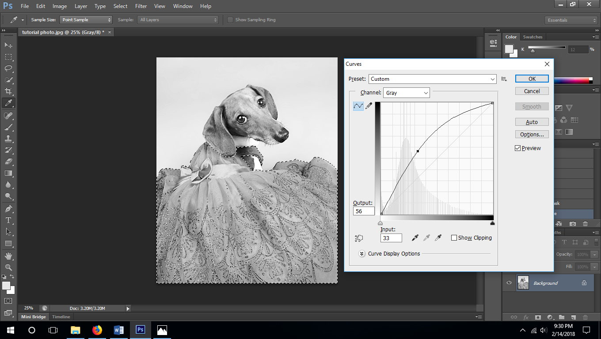

Just keep editing and lighting and darkening until you get what you want.
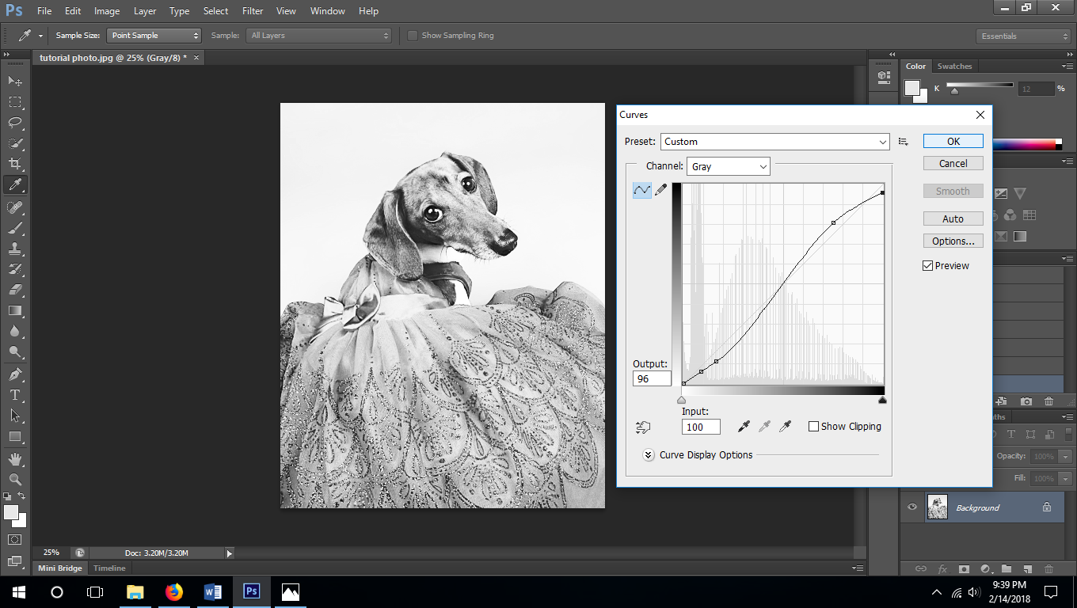
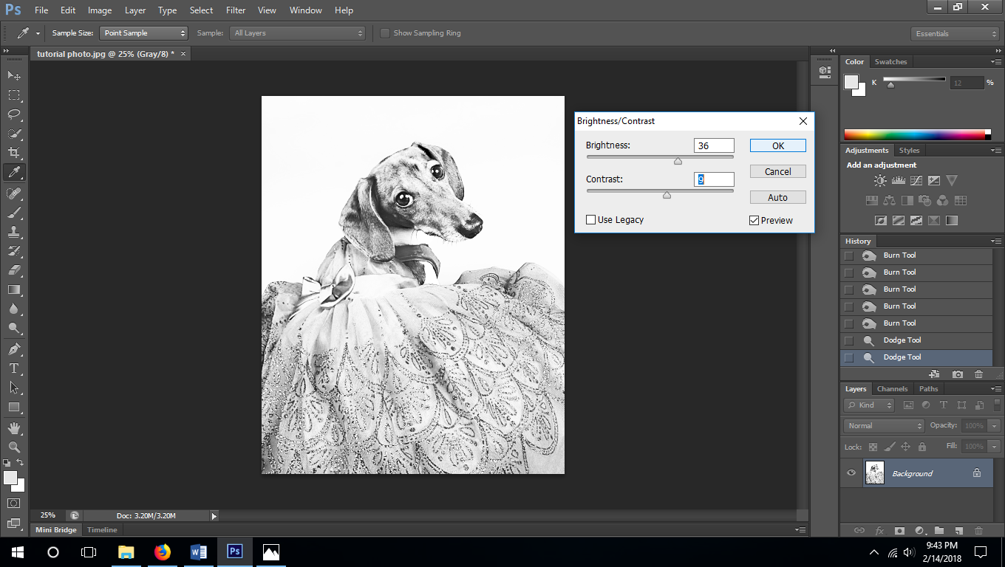

Once that is all said and done, you crop it how you want it and I just saved it as a .JPEG and uploaded it to the Glowforge app. I removed the protective cover off of the wood because the first time that I engraved it, it looked awesome… But the moment I removed the tape, I lost a lot of that detail. So I had to redo it and just clean it up a little bit.
