Assembly instructions
Once all is engraved and cut out:
1. start by putting the
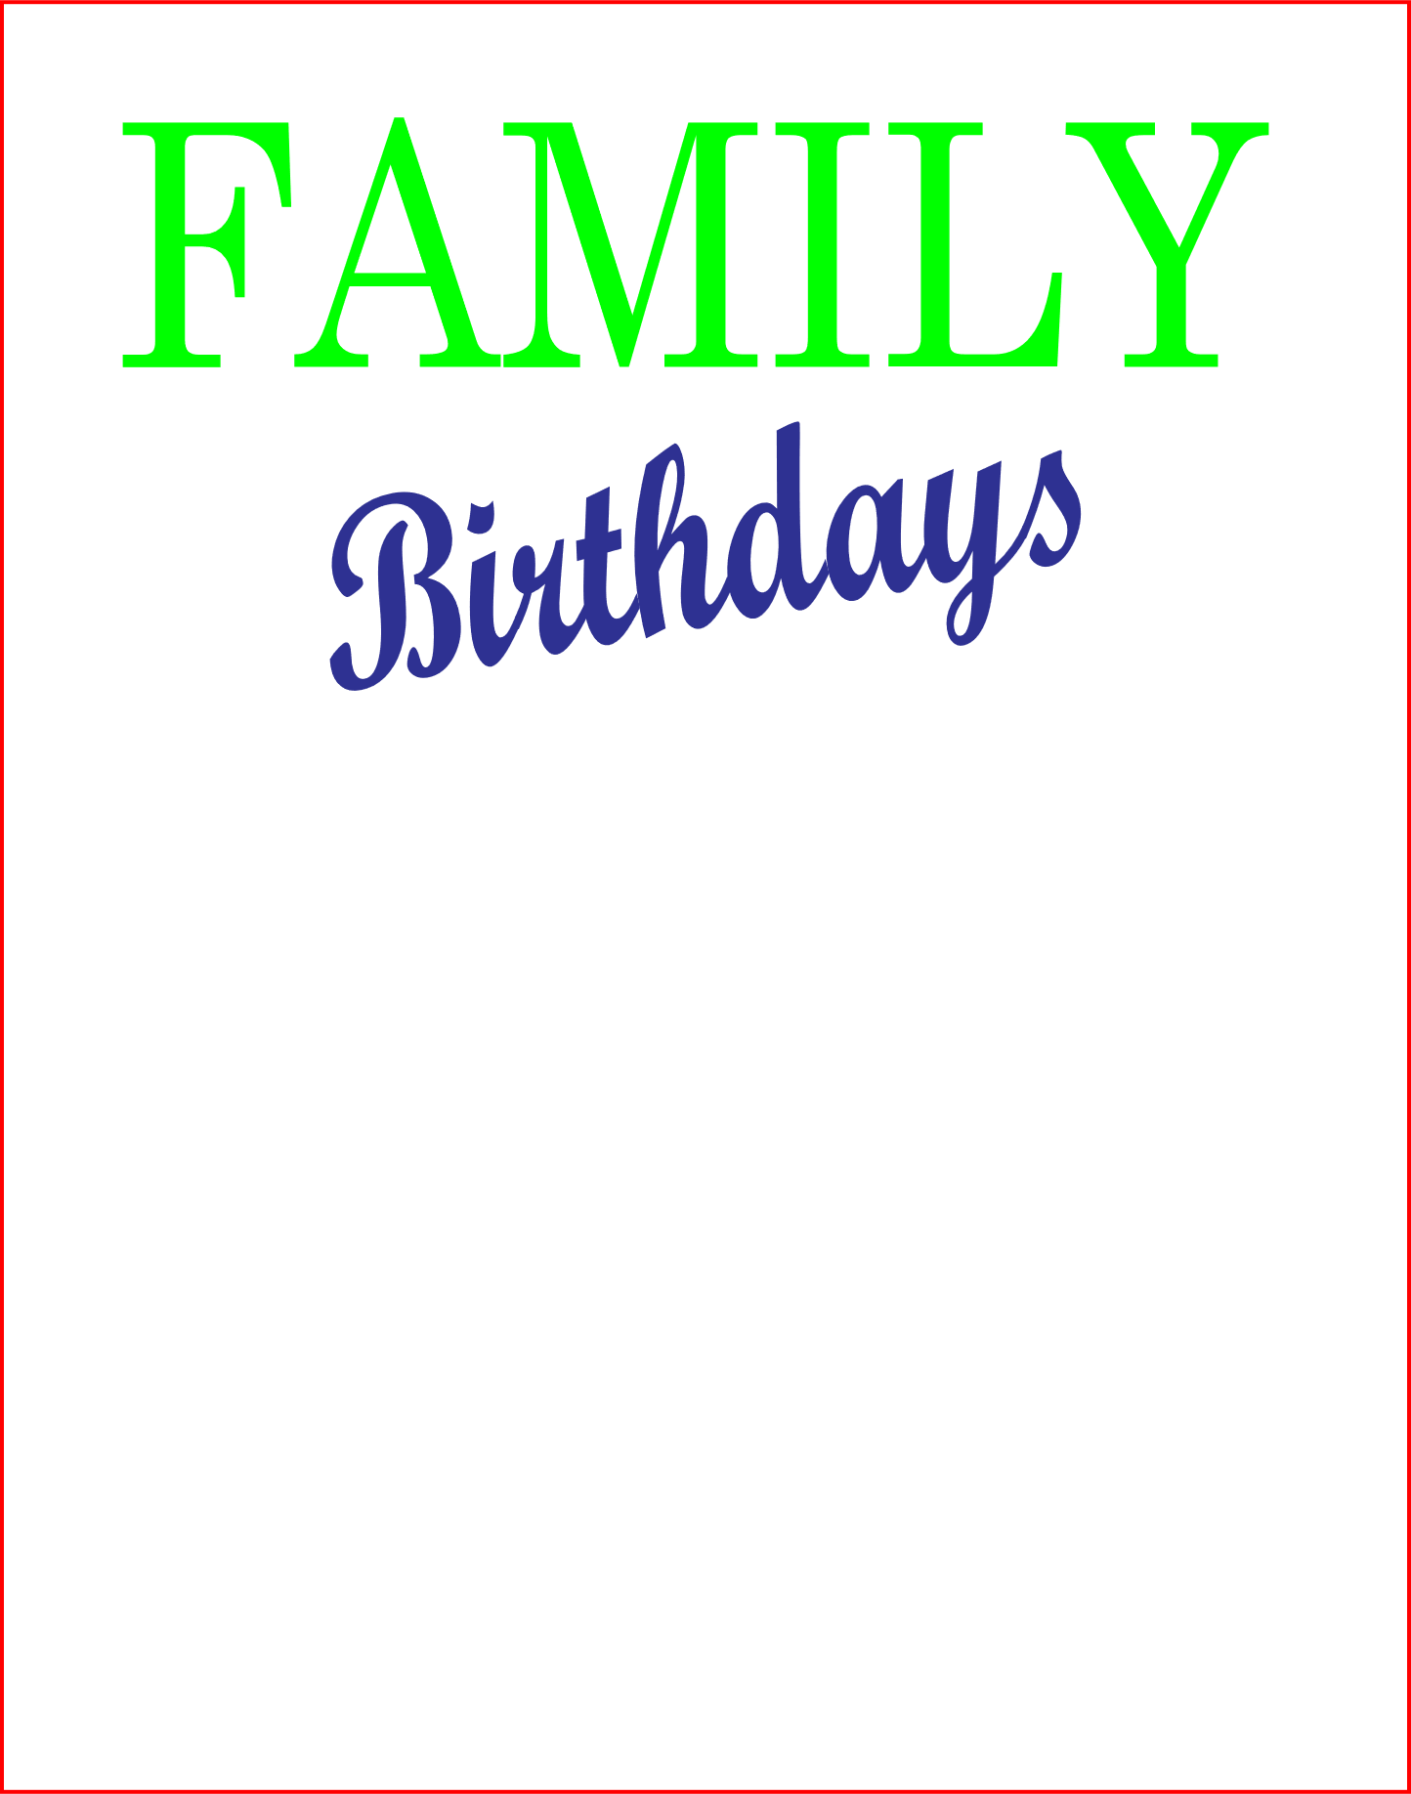
Flat on its back lettering up.
2. start at the bottom with the smaller and glue it aligned with the bottom edge and black side down.
Only small area as pictured below will be glued to the board.

3. Use one of the months as a spacer and glue the next hold down piece in place you will want to leave just a little space between and month and top hold down.
4. Let dry and complete working your way up.
