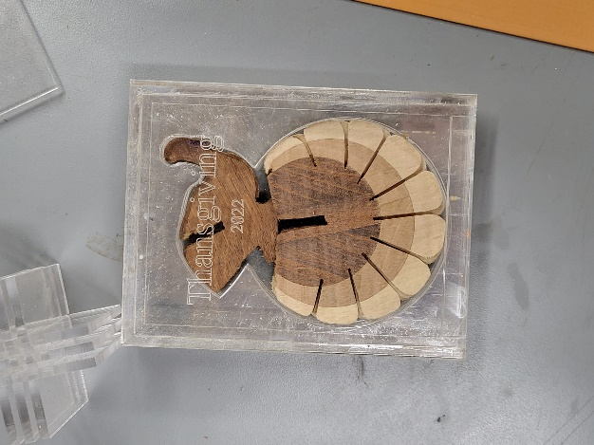
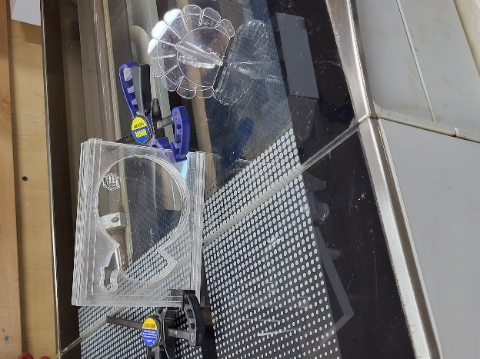
A Turkey Box for keeping or giving
My turkeys not made on GF
Ghost turkey watching construction
I made it out of clear acrylic just to show off. Obviously, you can make out anything you what. Keep in mind that the cutout around the turkey is tight and if you’re doing it in wood be cautious, that is, if you’re going to cut out the turkeys as well.

